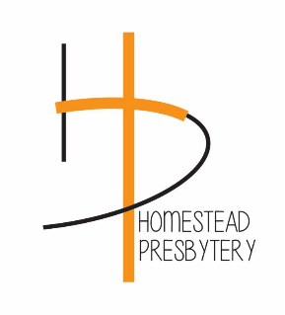
WORSHIP IS ESSENTIAL
Friends, We are getting questions about whether our churches have to open for in person worship this Sunday, following the President's statements today declaring that houses of worship are an essential service, and demanding that governors "re-open" churches this weekend.
First, we know houses of worship are essential - that has never been in question, nor do we need the government to confirm that. What has been in question is when it is wise and safe to return to in person worship services? While there are powers that governments have to determine when things close, or even to set limits on gatherings, it is the session that is responsible for evaluating when they determine it is wise and safe to return to in person worship. We strongly encourage each session to consider how and when they will make decisions about resuming in person worship and activities, taking into the best guidance of both government and scientific leaders
Our best advice: let's continue to stay connected and worship online. And if your session determines it is time to resume in person worship, do so safely and with grace toward those who are not ready to come back in person yet.

Stephen Earl, Interim Executive Presbyter
Sue Coller, Moderator of Council
Sue Babovec, Chair of the Disaster Response Team

