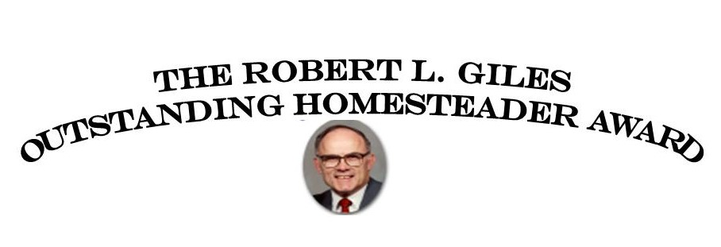

**Past Recipients**

1999

2000

2001

2002

2003

2004

2005

2006

2007

2008

2009

2010

2011

2012

2013

2014

2015

2016

2017

2018

Roger Harp

Lawrence Doerr

Ted (Bodie) Filipi

Ann Kirkpatrik

Don Ball

Sylvia Cross

Jeanne Giles

Donald R. Steiner

Ruth Ann Lyness

Patricia Brownawell

Ron Bump

Rev. Duane Westing

Harold R. Rainey

Cheryl Scott

Cheryl Rennick

Nancy Leavitt

Jimmy Shelbourn

Julie Hopp

Andrew McDonald

Frances McIntosh