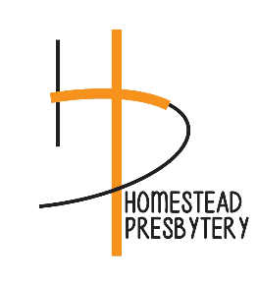

Partners in Mission for Christ
REMITTANCE FORM

Church:________________________________ PIN:______________ Date:___________
Address:_______________________________ City,State,Zip__________________________
Enclosed is/are:
- Unified Mission contribution in the amount of: $___________________
- Directed Mission total: (Please itemize on back) $___________________
- Special Offerings:
  - One Great Hour of Sharing $___________________
  - Pentecost (Congregation retains 40%) $___________________
  - Global Witness –Peace Making (Congregation retains 25%) $___________________
  - Christmas Joy $___________________
- Other Gift:
________________________________________________ $___________________
________________________________________________ $___________________
- Per Capita (Apportionment) $___________________
- TOTAL REMITTANCE (Total of items 1-5) $___________________
Submitted by:_______________________________ Please note any contact information changes here:
Phone:____________________________________ ___________________________________________
e-Mail:____________________________________ ___________________________________________:
OFFICE USE ONLY
Check #_________________________
Date:___________________________
Amount:_________________________
Please make the check payable to:
Homestead Presbytery
Please mail the check and this form to:
Synod of Lakes & Prairies
2115 Cliff Drive
Eagan, MN 55122-3327

